
FEEDSTOCK QUALITY ASSESSMENT AND DEFECT DETECTION
Department of Artificial Intelligence and Machine Learning
(For Office use only)
Application No.:
DATE:
- IP support service required (Tick the appropriate service)
  - Patent:
  - Trademark:
  - Copyright: 
  - Design:
- Point of contact (PoC)
  - 1st Point of Contact: Name: Mr. S. Balaji Mobile No. for contact: 7397363199 WhatsApp No.: 81899 26028
Email: balajisougoumar01@gmail.com
b) 2nd Point of Contact: Name: B. Adharsh Kumar Mobile No. for contact: 9025134945
WhatsApp No.: 9025134945
Email: adharshkumar2004@gmail.com
- 3rd Point of Contact: Name: Prasana. B Mobile No. for contact: 96003 33493
WhatsApp No.: 96003 33493
Email: prasanababu2005@gmail.com
- 4th Point of Contact: Name: Jai Akash. S
Mobile No. for contact: 6374885639
WhatsApp No.: 6374885639
Email: Sjaiakash8@gmail.com
- 5th Point of Contact: Name: A. Shaik Roshith
Mobile No. for contact: 9042059574
WhatsApp No.: 9042059574
Email: shaikroshith0000@gmail.com

COPYRIGHT PARTICULARS
CONTACT INFORMATION
- Details of the Applicant:
Name  (Official  Designation &  Address with Phone No) | Permanent  Address with Phone No | Age | Experience From To | Citizenship | Mobile No | Signature
Mr. S. Balaji | No.26,  Thiyagaraja street, Rajbhavan,  Pondicherry,  605001 | 26 | 11 months | INDIAN | 81899 26028 | 
B. Adharsh Kumar | No.43, 4th Cross, Rainbow Nagar,  Puducherry - 605011 | 21 | Pursuing  B. Tech | INDIAN | 9025134945 | 
Prasana. B | No.12, First Cross Street, M.G.R Nagar,  Moolakulam, Puducherry-605010 | 20 | Pursuing  B.Tech | INDIAN | 96003 33493 | 
Jai Akash. S | No:1, Chairman Illam,  Earipakkam X-Road,  Sooramangalam,  Puducherry,  605107. | 20 | Pursuing  B.Tech | INDIAN | 6374885639 | 
A. Shaik Roshith | No,24,  Hospital street, Mettupalayam,  Puducherry-605009 | 20 | Pursuing  B. Tech | INDIAN | 9042059574 | 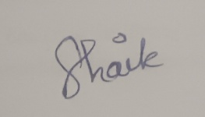

- Communication Details:
Name: Mr. S. Balaji
Address: No.26, Thiyagaraja street, Rajbhavan, Pondicherry-605001
Telephone No: 7397363199
Mobile No: 8189926028
E-mail Id: balajisougoumar01@gmail.com

Name: B. Adharsh Kumar
Address: No.43, 4th Cross, Rainbow Nagar, Puducherry–605011
Telephone No: 9025134945
Mobile No: 9025134945
E-mail Id: adharshkumar2004@gmail.com

Name: Prasana. B
Address: No.12, First Cross Street, M.G.R Nagar, Moolakulam, Puducherry-605010
Telephone No: 96003 33493
Mobile No: 96003 33493
E-mail Id: prasanababu2005@gmail.com

Name: Jai Akash. S
Address: No:1, Chairman Illam, Earipakkam X-Road, Sooramangalam, Puducherry,605107.
Telephone No: 6374885639
Mobile No: 6374885639
E-mail Id: Sjaiakash8@gmail.com

Name: A. Shaik Roshith
Address: No,24, Hospital Street, Mettupalayam, Puducherry-605009
Telephone No: 9042059574
Mobile No: 9042059574
E-mail Id: shaikroshith0000@gmail.com

1. INFORMATION FOR COPYRIGHT FILING
- Type of creation (Please tick ) o Artistic Works (Poster) o Musical Works o Literature Works o Dramatic Works o Books o App
o Coding/Hardware

Annexures Required:
1. For APP, Coding/Software
Object Code Source Code
are required. This has to be given in 2 CDS/2 Pen drives for filing. 2. For Books, Artistic works (Posters), Literature Works 2 Hard copies have to be given for filing.
3. For Musical, Dramatic works
The work has to be given in 2 CDS/2 Pendrives for filing.

- Provide brief description of the functionality/use of your creation.
An AI-Powered Visual Quality Prediction and Defect Detection System is an intelligent industrial solution that uses deep learning and computer vision technology to continuously analyze raw material images and identify defects in real time. Industrial cameras capture images of raw materials such as steel surfaces, automobile components, or machine parts during the manufacturing process. These images are processed using deep learning models to detect minute surface defects such as cracks, scratches, pits, inclusions, and irregularities. The system automatically classifies the material quality and reports defective components to the admin or quality control department through a monitoring dashboard. This reduces manual inspection effort, improves accuracy, and enables faster quality assessment in Industry 4.0 production environments. Additionally, the detected defect data and prediction results are stored for future analysis, helping industries improve manufacturing quality, reduce production losses, and achieve automated smart inspection systems.

3.Whether the work is published or unpublished:
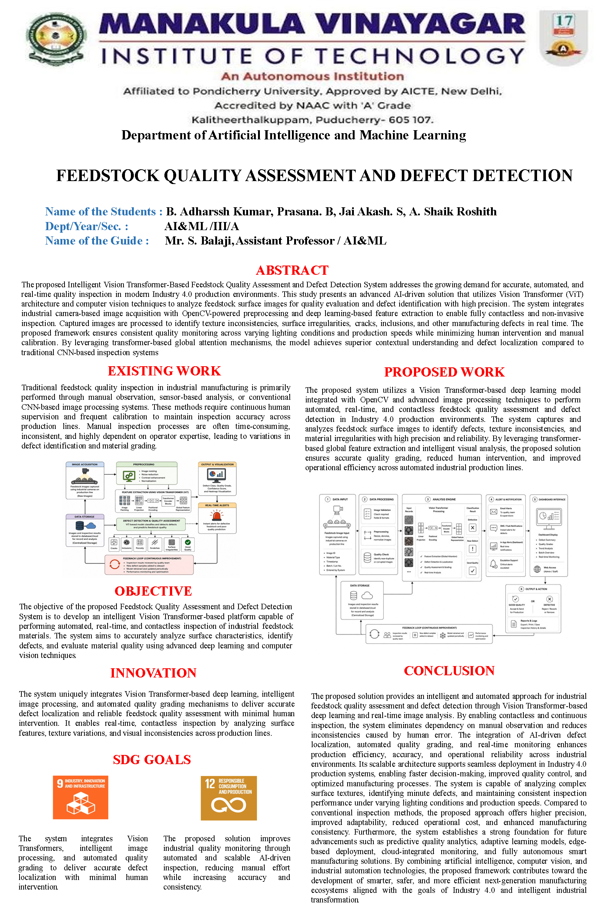
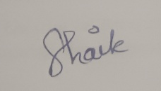
Unpublished
5
^{th}
Author/Inventor
Name: A. Shaik Roshith

Date:
SIGN:

Signature of the Inventor(s)

1
^{st}

Author/Inventor

Name:

Mr. S. Balaji

Date

SIGN

:

2
^{nd}
Author/Inventor

Name:

B. Adharsh Kumar

Date:

SIGN
:

3
^{RD}
Author/Inventor

Name:

Prasana. B

Date:

SIGN:

4
^{th}
Author/Inventor

Name: Jai Akash. S

Date:

SIGN:

DESIGN PARTICULARS

Project Title: FEEDSTOCK QUALITY ASSESSMENT AND DEFECT DETECTION
Inventor Details:
Inventor 1 |  | Name: Mr. S. Balaji |  | Designation: Assistant Professor / AI&ML
 |  | Phone No: 8189926028 |  | Mail ID: balajisougoumar01@gmail.com
Inventor 2 |  | Name: B. Adharsh Kumar |  | Designation: Student
 |  | Phone No: 9025134945 |  | Mail ID: adharshkumar2004@gmail.com
Inventor 3 |  | Name: Prasana. B |  | Designation: Student
 |  | Phone No: 96003 33493 |  | Mail ID: prasanababu2005@gmail.com
Inventor 4 |  | Name: Jai Akash. S |  | Designation: Student
 |  | Phone No: 6374885639 |  | Mail ID: Sjaiakash8@gmail.com
Inventor 5 |  | Name: A. Shaik Roshith |  | Designation: Student
 |  | Phone No: 9042059574 |  | Mail ID: shaikroshith0000@gmail.com
Signature of the Inventors
Inventor 1 | Inventor 2 |  | Inventor 3 |  | Inventor 4

INFORMATION FOR DESIGN FILING
INPUT
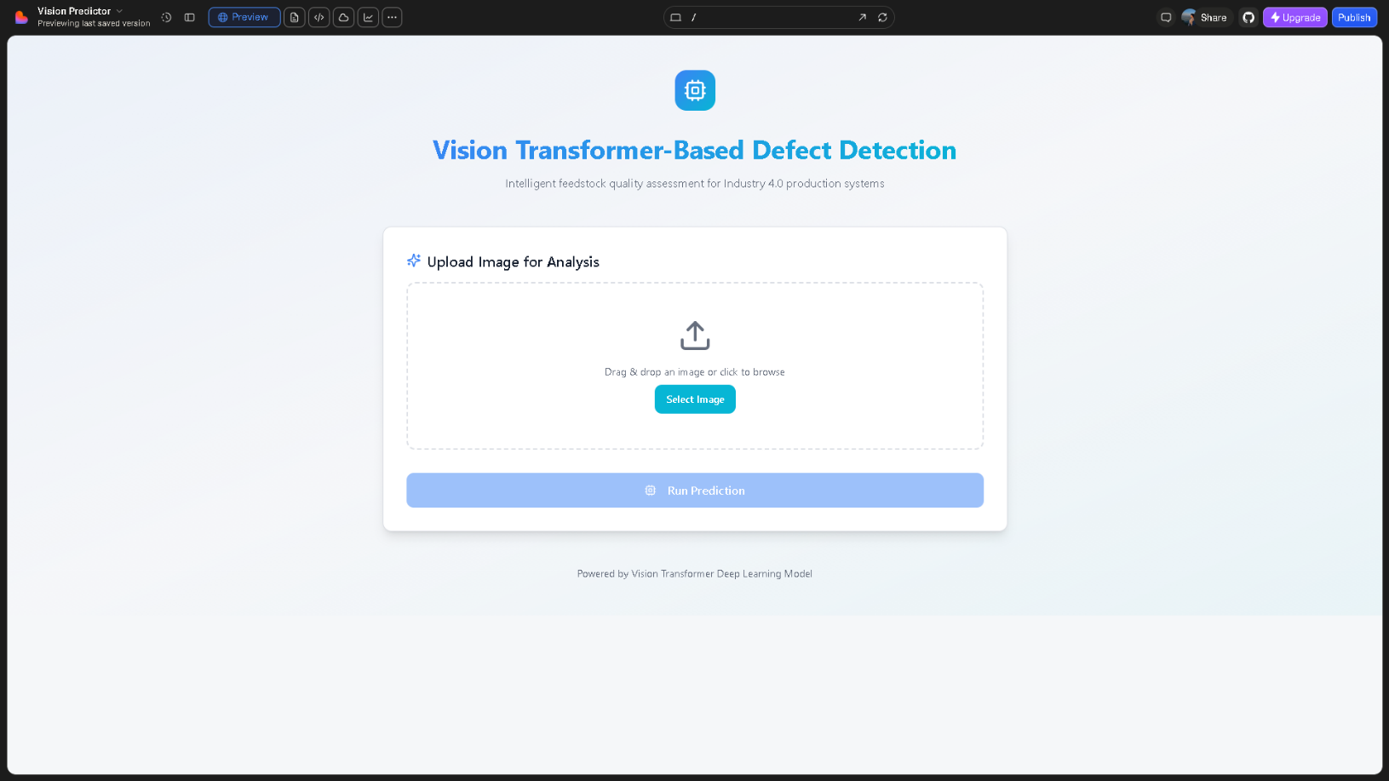

CODE
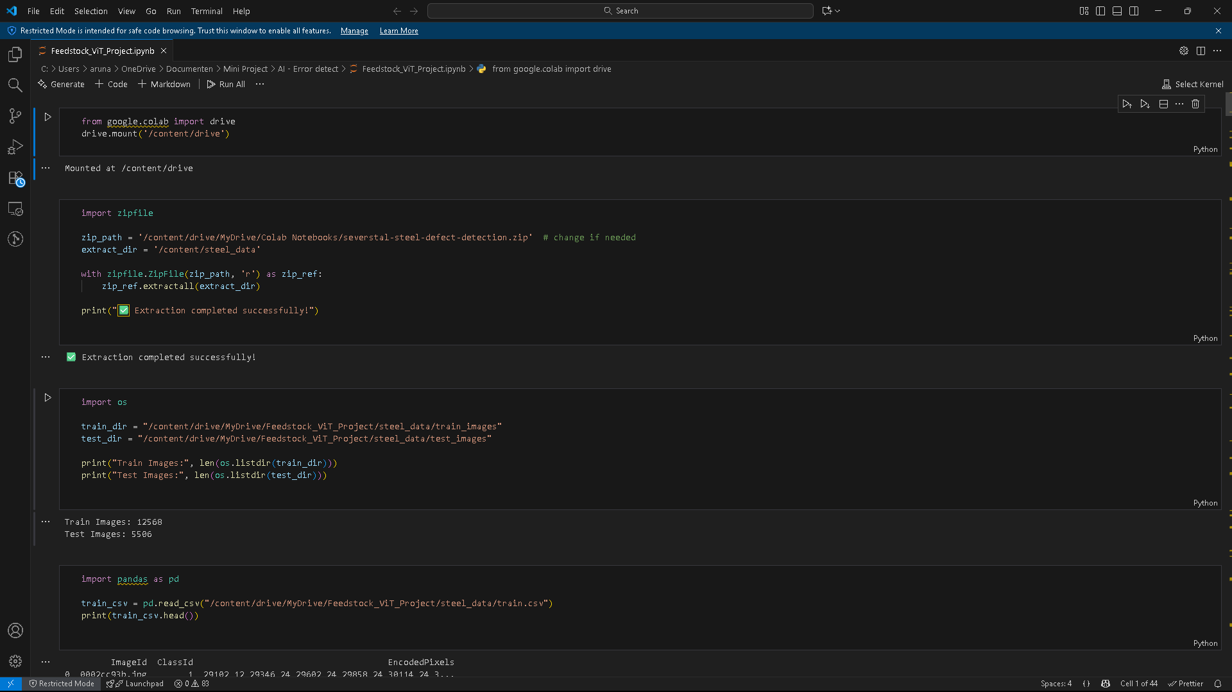
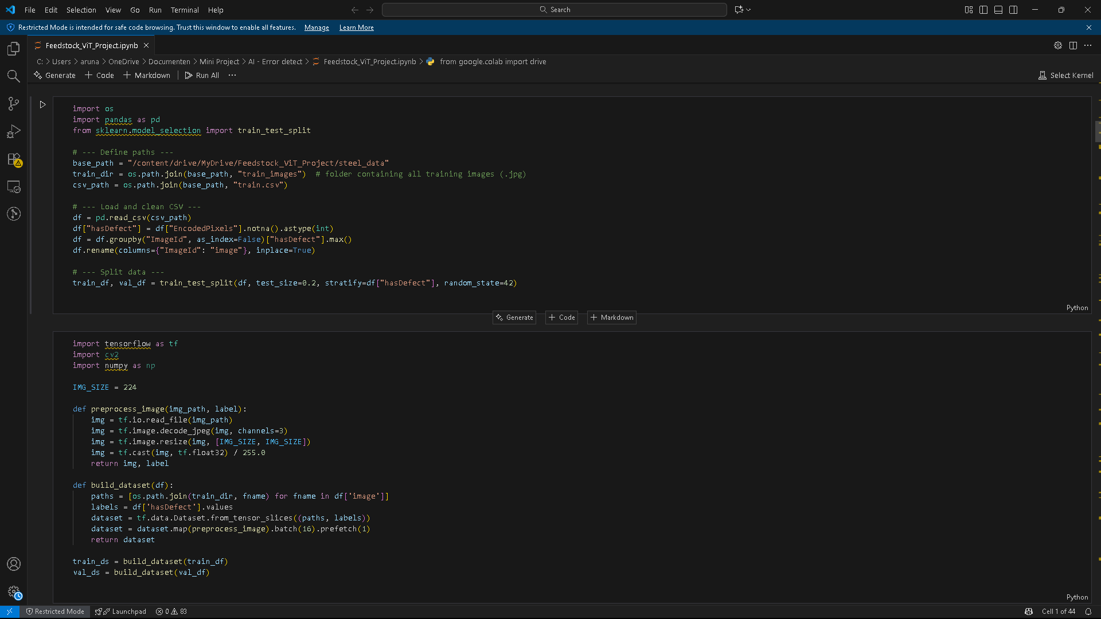

OUTPUT
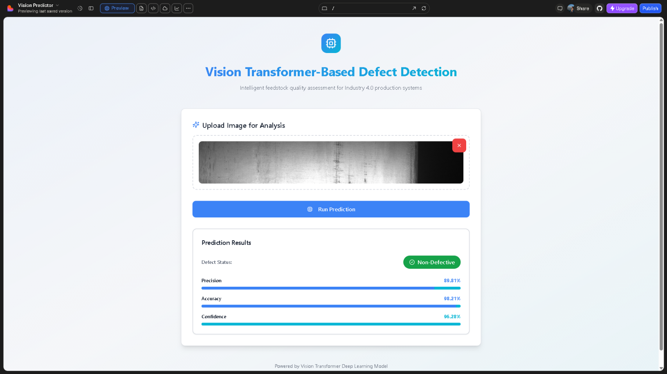

Abstract: (Minimum 750Words)
The rapid advancement of artificial intelligence and computer vision technologies has greatly improved the efficiency and accuracy of industrial quality inspection systems. An AI-Powered Visual Quality Prediction and Defect Detection System is an intelligent manufacturing solution designed to continuously monitor and analyze raw material images using deep learning and image processing techniques. The system captures high-resolution images of industrial raw materials such as steel surfaces, automobile parts, or machine components and automatically detects defects such as cracks, scratches, dents, inclusions, and surface irregularities. The collected image data is processed using deep learning models to classify materials as good or defective and provide accurate quality assessment results.
This technology has become highly important in modern Industry 4.0 production systems because it supports automated quality inspection, reduces dependency on manual labor, minimizes human error, and improves production efficiency. The system uses industrial cameras and computer vision techniques integrated with deep learning frameworks such as TensorFlow or PyTorch to analyze product quality in real time. The detected defects and prediction results are transmitted to monitoring dashboards or cloud-based systems, allowing administrators and quality control engineers to monitor production quality remotely. The system can also generate automatic alerts whenever defective materials are detected, enabling immediate corrective action and reducing production losses.
Compared to traditional inspection methods, which rely heavily on manual observation and periodic checking, AI-based defect detection systems provide automated, fast, and highly accurate inspection. The architecture of the system generally consists of three major layers: image acquisition layer, processing and analysis layer, and monitoring layer. The image acquisition layer includes industrial cameras responsible for capturing raw material images, the processing layer applies preprocessing and deep learning models for defect identification, and the monitoring layer displays the results through dashboards or reporting systems. Cloud computing and data storage technologies also play an important role in storing large amounts of inspection data securely and making it accessible for future analysis and quality tracking.
One of the major advantages of the AI-Powered Visual Quality Prediction System is real-time defect detection, which allows industries to identify defective materials before they proceed further in the production line. This reduces material wastage, production downtime, and manufacturing costs while improving product reliability and customer satisfaction. The system is especially beneficial in industries such as automobile manufacturing, metal processing, electronics, textile production, and machinery manufacturing where precision and quality control are critical. AI-based inspection systems also improve production data management by automatically maintaining digital inspection records and reducing manual documentation.
However, the system also faces certain challenges and limitations. The accuracy of the deep learning model depends heavily on the quality and size of the training dataset. Variations in lighting conditions, camera angles, and image quality may affect prediction accuracy. In addition, high computational requirements, hardware costs, and integration with existing industrial systems can impact implementation. Despite these challenges, the future of AI-based quality inspection is highly promising due to rapid advancements in deep learning, computer vision, edge computing, and Industry 4.0 technologies. Future systems are expected to include fully automated smart factories, AI-driven predictive maintenance, robotic inspection systems, and real-time industrial analytics.
In conclusion, the AI-Powered Visual Quality Prediction and Defect Detection System is an advanced and efficient industrial solution that enables automated quality inspection, real-time defect detection, and intelligent monitoring. By combining computer vision, deep learning, cloud technologies, and automated reporting systems, the system improves manufacturing quality, reduces operational costs, and enhances industrial productivity. Although challenges related to accuracy, hardware integration, and computational requirements still exist, continuous advancements in AI technologies are making industrial inspection systems smarter, faster, and more reliable. Therefore, AI-based visual quality prediction systems play a major role in the development of modern smart manufacturing and Industry 4.0 production environments.

Application :( Minimum 500 Words)

1. Automated Raw Material Inspection
AI-based quality inspection systems automatically analyze raw material images such as steel sheets, automobile parts, and machine components to detect defects before production begins. This reduces manual inspection time and improves manufacturing accuracy.

2. Surface Defect Detection
Deep learning models identify minute surface defects such as cracks, scratches, dents, pits, and corrosion in industrial materials. The system helps industries maintain high product quality standards.

3. Real-Time Production Line Monitoring
Industrial cameras continuously capture images from conveyor belts and assembly lines. The AI system processes these images in real time and instantly detects defective products during manufacturing.

4. Automobile Component Quality Assessment
The system is used in automobile industries to inspect engine parts, gears, metal sheets, and other components for manufacturing defects. Early detection prevents defective parts from reaching customers.

5. Smart Factory Automation
In Industry 4.0 environments, the system supports fully automated quality control by integrating AI, computer vision, and industrial monitoring systems. This improves production efficiency and reduces human dependency.

6. Defect Reporting and Alert System
Whenever defects are detected, the system automatically generates reports and sends alerts to quality control engineers or administrators. This enables quick corrective action and minimizes production loss.

7. Predictive Maintenance Support
Continuous monitoring of machine parts and raw materials helps identify wear and damage at early stages. This supports predictive maintenance and prevents unexpected machine failures.

8. Industrial Data Analysis and Record Management
The system stores inspection results, defect images, and quality reports in databases or cloud platforms. Industries can use this data for quality analysis, auditing, and production optimization.

9. Metal and Steel Industry Inspection
AI-based defect detection systems are widely used in steel and metal industries to inspect surface quality, detect rolling defects, and ensure compliance with industrial standards.

10. Electronics and Precision Manufacturing
The system can inspect electronic components, circuit boards, and precision-manufactured products where even tiny defects can affect performance and reliability.

Advantages :( Minimum 250 Words)

1. Real-Time Defect Detection

The system continuously monitors raw material and product images to detect defects instantly during the manufacturing process.

2. Automated Quality Inspection

AI-based inspection reduces the need for manual quality checking and improves consistency in defect identification.

3. Early Detection of Manufacturing Defects

Minute defects such as cracks, scratches, dents, and surface irregularities are identified at early stages, preventing defective products from entering production.

4. Reduced Production Costs

Early defect identification minimizes material wastage, product rejection, rework, and maintenance costs in industries.

5. Improved Product Quality

The system ensures high-quality manufacturing standards by accurately classifying defective and non-defective materials.

6. Increased Industrial Productivity

Automated inspection speeds up the quality control process and improves overall production efficiency.

7. Automatic Data Collection and Storage

Inspection results, defect images, and quality reports are stored automatically in databases or cloud systems for future analysis.

8. 24/7 Continuous Monitoring

The system operates continuously without interruption, enabling round-the-clock industrial quality inspection.

9. Easy Access to Inspection Reports

Quality engineers and administrators can easily access defect reports, production history, and inspection records through dashboards or monitoring systems.

10. Supports Smart Manufacturing and Industry 4.0

The project contributes to the development of intelligent factories by integrating artificial intelligence, computer vision, and automated industrial monitoring systems.

Existing System Sample Drawing (not mandatory)
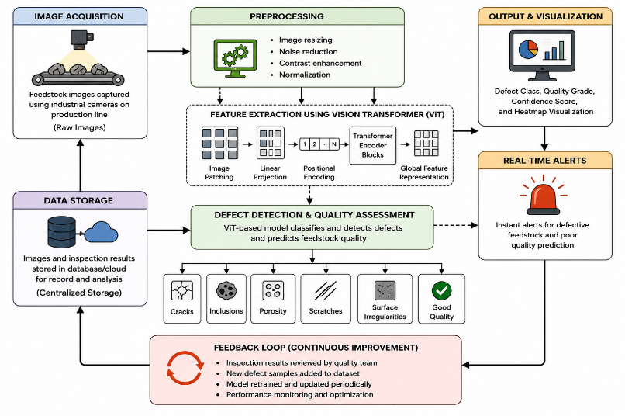

Proposed system Sample Diagram
